**Lab 3: About all Components**

Building a ReactJS application with a user interface that requires the user to input a list of questions and answer options for each question. Display the questions and answer options to the user and check whether the user has selected the correct or incorrect answer.

# Create Components

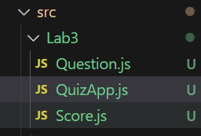

## Create a main Component to manage the entire Quiz application:

* Create a Component named **'QuizApp'**.
* In this Component, you can use state variables to store information such as the current question, selected answer options, and score.

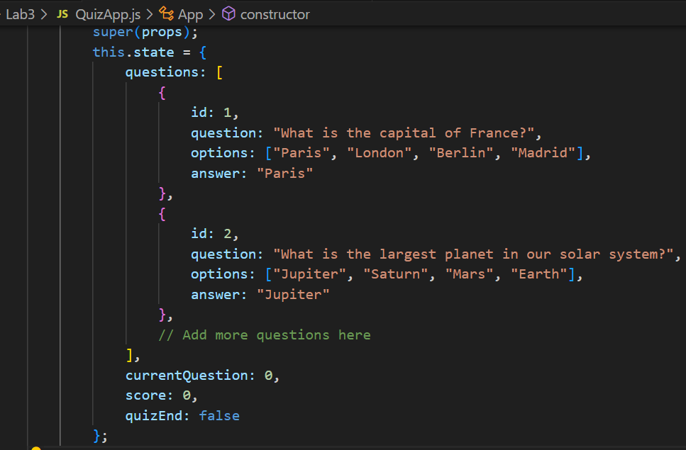

* Use methods to handle events such as selecting an answer, checking the answer, and moving to the next question.

## Create a child Component to display the question and answer options to the user:

* Create a Component named **'Question'** or any desired name.
* In this Component, you can pass props such as the question, list of answer options, and the selected answer.
* Use methods to handle events such as selecting an answer and submitting the answer.

## Create a child Component to display the user's result after completing the Quiz:

* Create a Component named **'Result'** or any desired name.
* In this Component, you can pass props such as the user's score.
* Display the user's result and provide options such as replaying or sharing the result.

# Check the answer

* When the user selects an answer option, check if that answer is correct or incorrect.
* If the answer is correct, increase the user's score.
* Move to the next question by incrementing the current question counter.

# Display the result

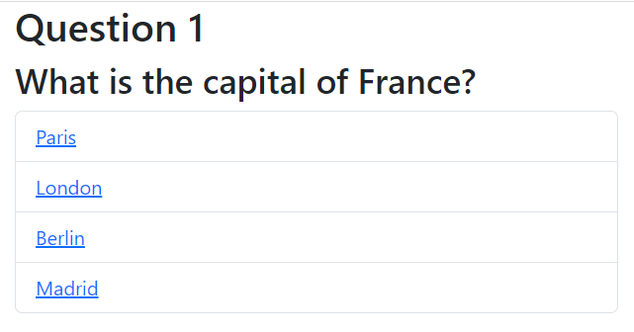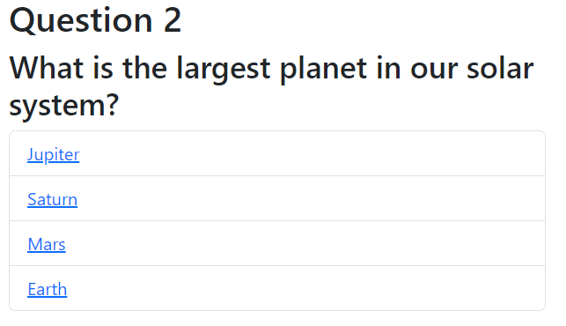

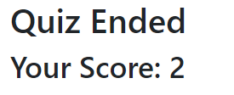

When the user completes the Quiz, display the final result and the user's score.

Use a child Component to display the result and score.